Dis-Bulgaria-Neolithic-Ceramic-Figurine-Female-VI Millennium BCE-91 mm

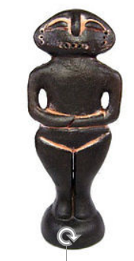 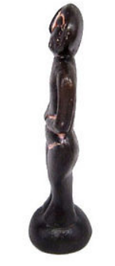 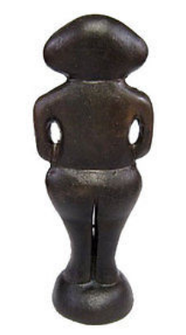 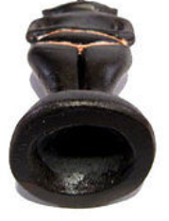

**Neolithic Idol made of black clay decorated with white ohra- VI Millennia B.C. – Ceramic.**

**The Original was found in the ruins of a Neolithic settlement in the region of STARA ZAGORA , BULGARIA). And at the moment the Original is for a display in the Archaeological Museum in Stara Zagora.**

**The Replica is made of a ceramic material and painted with special laquer to get close to the original paint.**

**Size- 91/36/27 mm;               Weight- 28 g;**